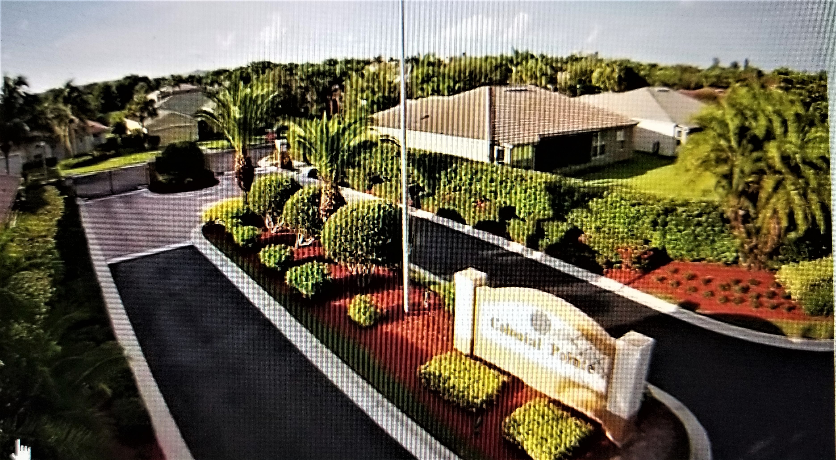
Colonial Pointe Newsletter
JUNE 2025 matt@sandcastlePMB.com 239-466-3330
All communications are by email or blast. Please make sure Matt has your correct information to stay informed.
HURRICANE SEASON IS COMING SOON……..
There are several websites that have excellent information for getting prepared. For Lee County in general these are : www.leegov.com/hurricane. Another useful site is www.visitfortmyers.com/sites/default/files/images/family-emergency-plan.pdf

NOW is the time to review your plan for hurricane season. Make a hurricane box/kit to have on hand. Include a first aid kit, sunscreen, insect repellent, flashlight and batteries. Get a car charger for your cell phone. Keep a list of emergency numbers in your kit too. Keep your car filled with gas and check tire pressure and fluid levels. Keep a supply of cash, refill medications (for you and your pets) as well as food for your pets. Purchase gallon jugs of water – 1 gallon per person per day is recommended.
If you have a generator – check now to see that it is in working order. Purchase gas and store safely in your garage.
If you are leaving the community for any length of time and are putting up hurricane shutters, please be aware of the following:
As per ARC Guidelines:
Bare metal shutters can be deployed 5 days before and must be removed 5 days after a storm declared to be a hurricane or tropical storm by the National Weather Service.
Hurricane Shutters which are painted the home color, clear, fabric or factory painted that blends with house color, may be installed and remain in place.

PICK UP A COPY OF WINK NEWS HURRICANE GUIDE 2025 AT ANY PUBLIX SUPERMARKET – IT HAS A WEALTH OF USEFUL IMFORMATION

MOST IMPORTANT – STAY SAFE AND HEALTHY

