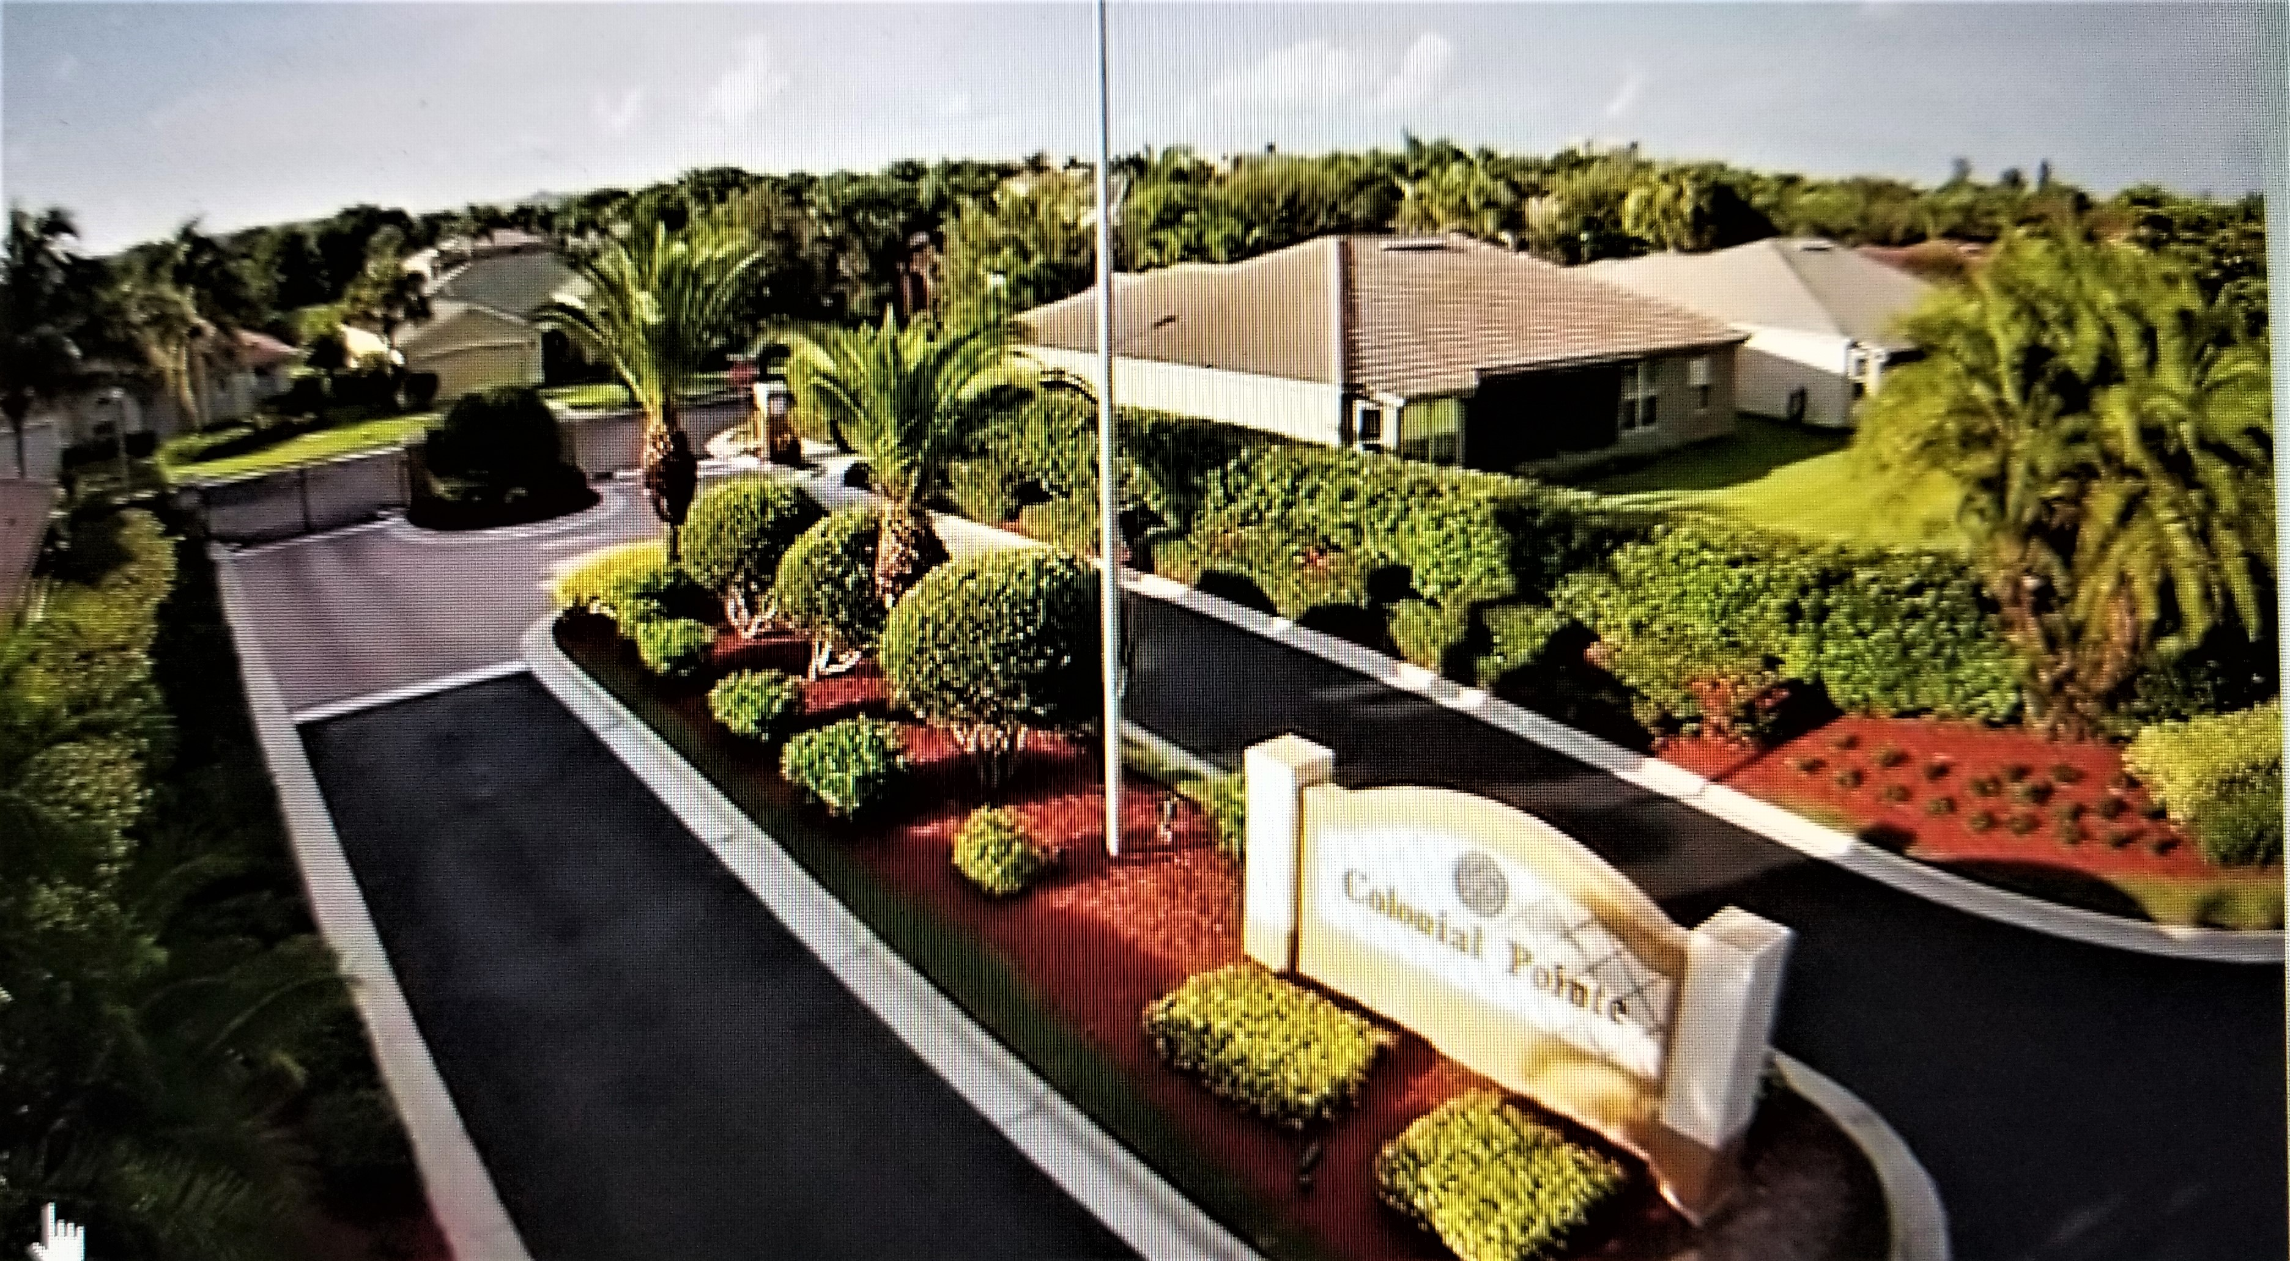
Colonial Pointe Newsletter
JUNE 2025 PART 2 matt@sandcastlePMB.com 239-466-3330
All communications are by email or blast. Please make sure Matt has your correct information to stay informed.
HURRICANE SEASON INFORMATION Continued……
There are several websites that have excellent information for getting prepared. For Lee County in general these are : www.leegov.com/hurricane. Another useful site is www.visitfortmyers.com/sites/default/files/images/family-emergency-plan.pdf
Since Hurricane Ian, Helene and Milton, the Insurance industry has made many changes to policies and requirements for homeowners. Check your policy regarding your coverage, because you will want to know that you have the right coverage. Check the dwelling amount listed on the policy – it needs to be enough to rebuild your home should you sustain major damage. Check with your insurance advisor, a builder, or someone who can advise you on the amount you would need if you sustain major damage to your home, or if it is destroyed. If you do not have enough, consider increasing it.
It is a good idea to review your coverage, deductibles and renewal dates, and ensure your coverage is in full effect. Make sure you have made a payment before the due date, to ensure that you have coverage. If you have a mortgage, contact your mortgage lender to make sure they have made payments.
On top of making sure your home is properly insured, check your flood and auto coverage. Many people are told they don’t need flood insurance because they are not in a flood zone, BUT WE ARE ALL IN A FLOOD ZONE!
It is a good idea to photograph/video the inside of your home, furniture, appliances etc., because if you do have to make a claim, major or otherwise, you can show the insurance adjustor your pictures of the before and this will help with the claims procedure. Save receipts for any repair you do to show the inspector.
We do hope that we will not experience a bad hurricane season this year, but regardless we should be prepared in advance of any major storm/hurricane. Check on your neighbors to see if they need any help with storm preparedness. Don’t forget to put your “hurricane box” together, and ensure that the necessary medications have been ordered in advance. Finally, don’t forget your pets – food, bedding and medications (and a crate if going to a shelter).
After a storm, there will be clean up! Waste Pick-up will have priorities regarding collection. The first priority will be raw garbage, such as regular food, fruit or vegetable waste. Second will be normal household garbage, and thirdly yard waste. The last priority will be construction debris.
Contact Unincorporated Lee (239) 533-8000 for Storm Debris Removal information.

