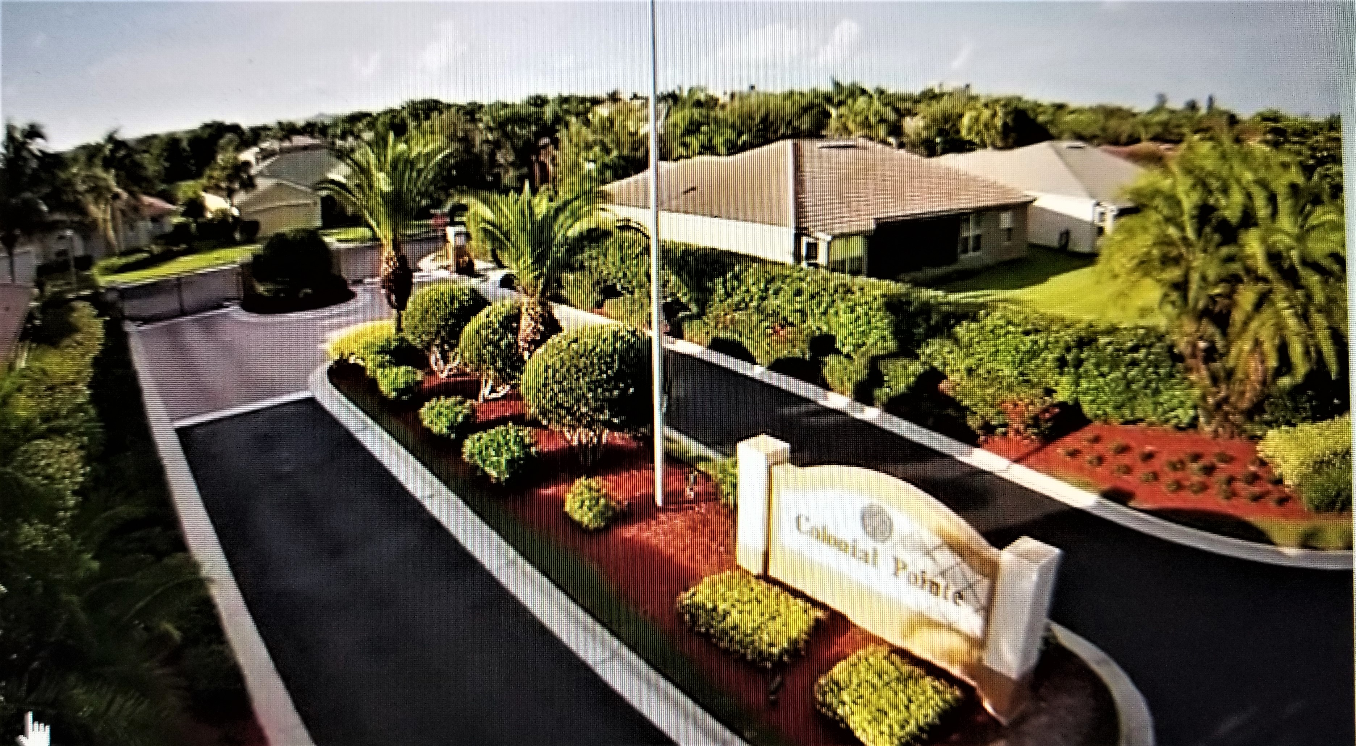
Colonial Pointe Newsletter
February 2024 matt@sandcastlePMB.com 239-466-3330
All communications are by email or blast. Please make sure Matt has your correct information to stay informed.
Annual General Meeting
The Annual General Meeting will take place on April 16, 2024 at Pine Ridge Community Center at 6pm.
The election of the 2024 Board will take place at this meeting.
Homeowners are encouraged to attend this meeting.

SPRING is coming …………….
It’s that time of year again when homeowners need to look at their properties and decide whether they need to
Repair, Repaint or Replace
Please take a look at your mailboxes, driveways and roofs.
If you need to replace your mailbox, the approved mailbox for our community can be ordered and replaced by:
ASAP Mailbox and More, Inc.
Telephone 877-272-7624
Power-washing your driveway and roof maintains the pristine environment that we enjoy in our community, and helps with keeping up the property values.
Weeding and mulching is also an opportune time right now.
By taking care of your property, you help maintain our beautiful community.
Have you thought about becoming a Board Member?
If you have strong opinions (and we all do), then this may be for you.
Consider being a voice for your neighbors and community.
The community cannot grow and stay healthy without input from homeowners.

Trash, Recycling and Horticulture
Trash, Recycling and Horticulture remain our biggest headache!
These items may be placed at the curb after 9:00am on Monday, the day before collection. Trash cans and Recycling containers must be removed from the curb and stored out of sight by midnight on the day of collection.
NO Horticulture should be placed at the curb before 9:00am on the day before collection.

Board Vacancies
Three Board seats will be up for election in April.
You will receive information in the mail in March on how to vote for a candidate or how to state your intent to run.

