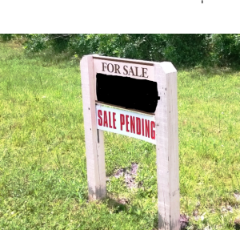

**Approved Real Estate Sign Dimensions**

**Sign is 12 inches high X 28 inches long**

**Posts are 4 inches X 4 inches X 4 feet long with 3 feet exposed**

**Lettering similar to sample**

**Open House hours are Noon to 5:00PM Saturdays and Sundays only.**

|  |  |
| --- | --- |
| **Please contact the Property Manager, Matt Deavers at Sandcastle Property Management to arrange for the gates to be opened. Matt can be contacted at his office: 239-466-3330 or by email matt@sandcastlepmb.com** | |
|  |