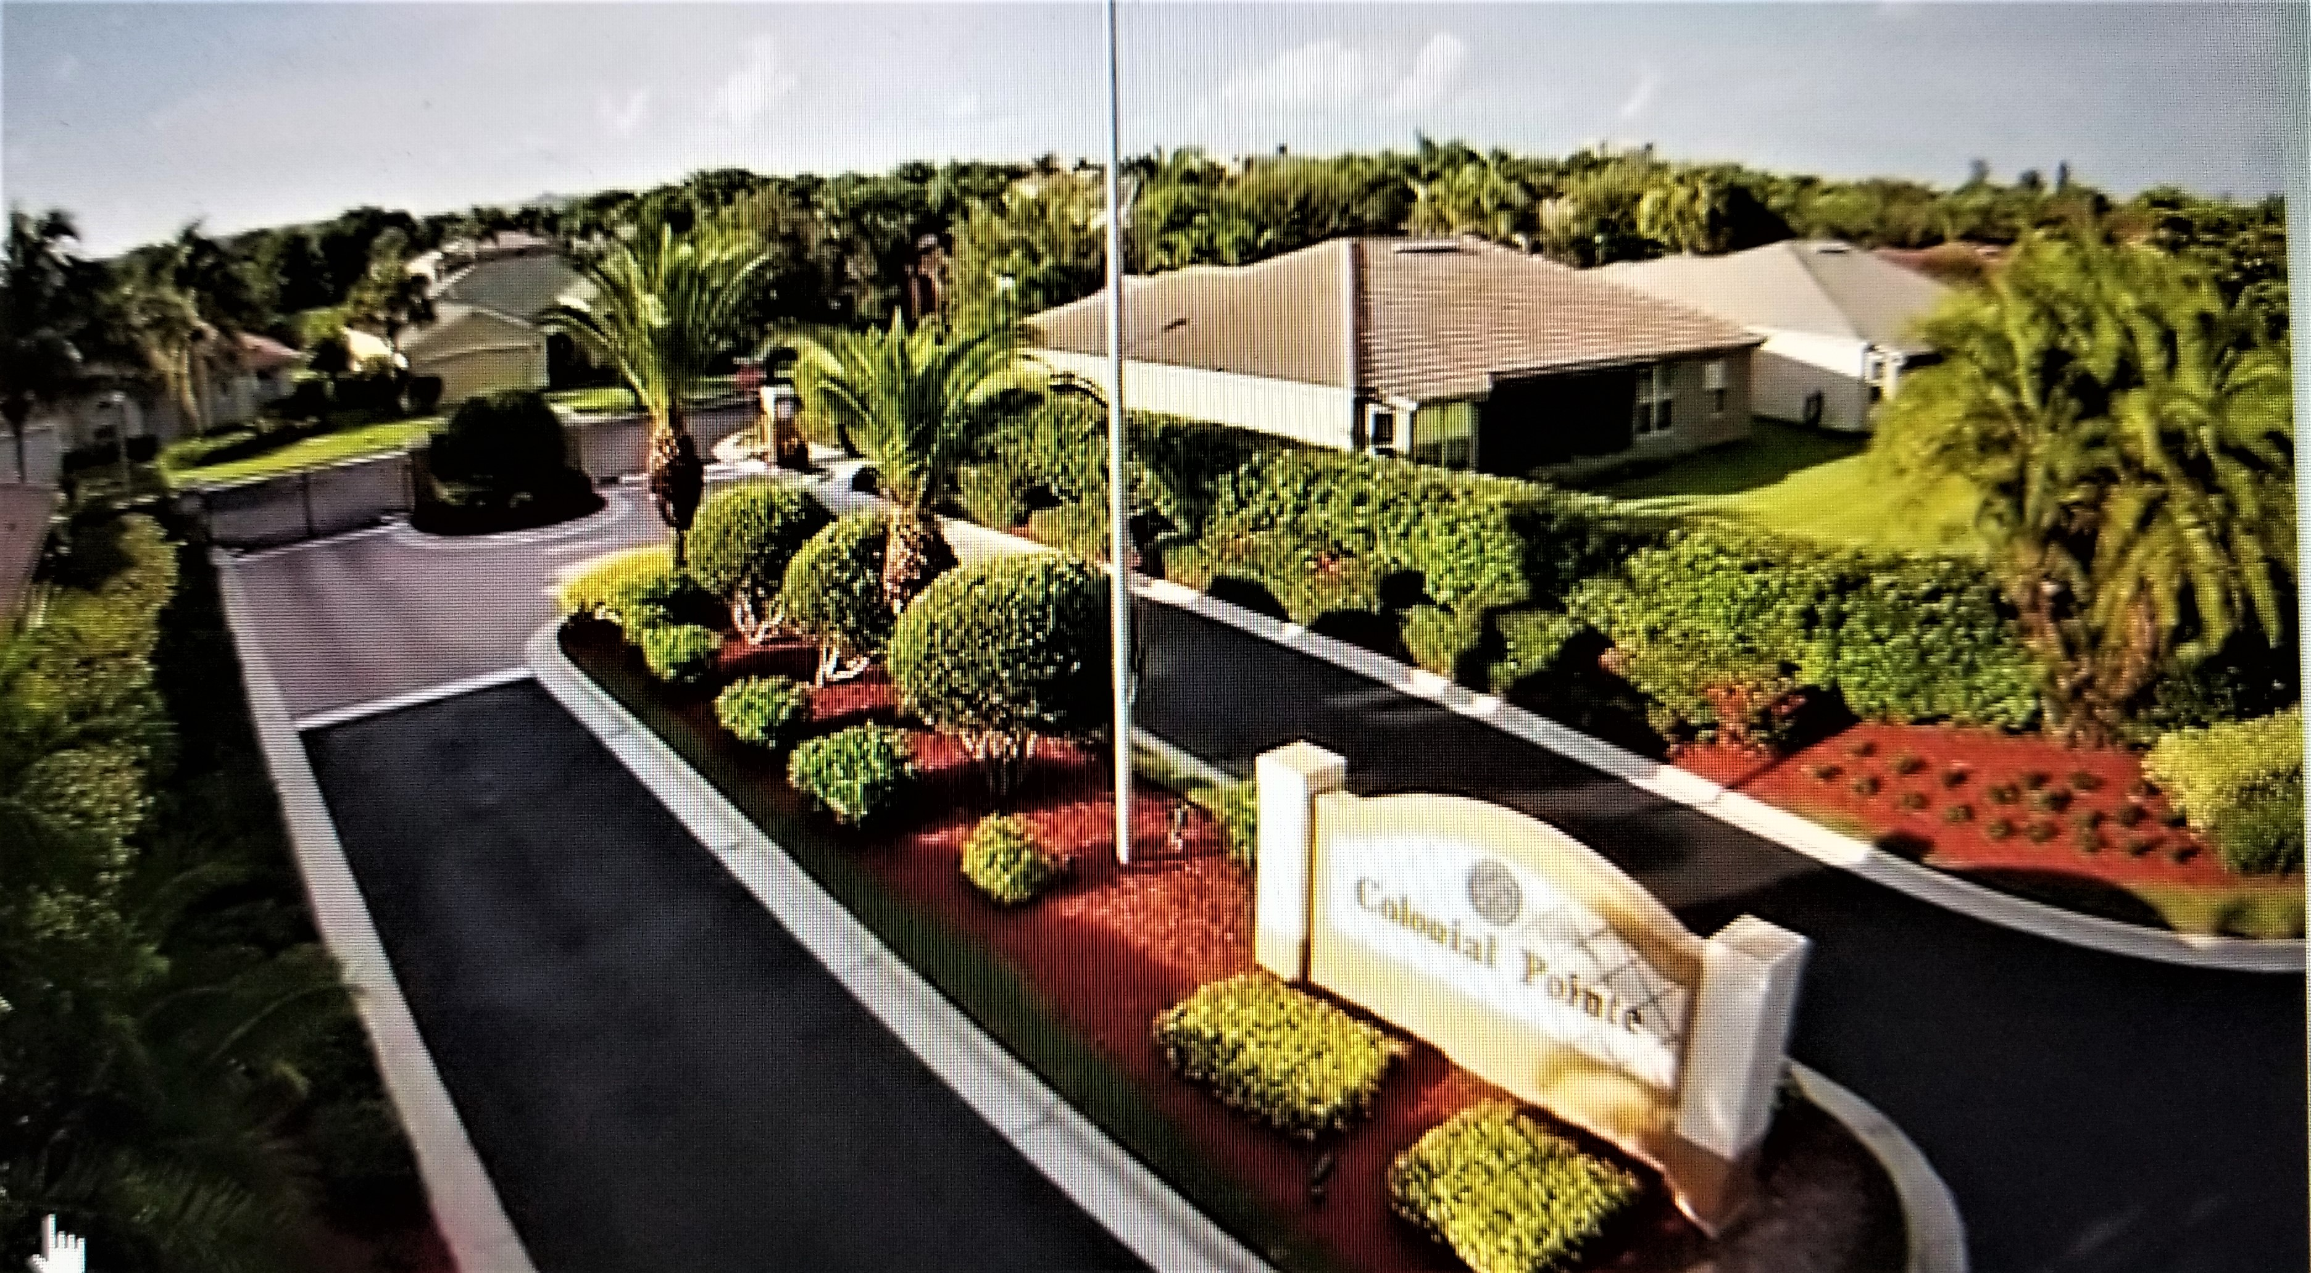

Colonial Pointe Newsletter
APRIL 2025 matt@sandcastlePMB.com 239-466-3330

THE DO’S AND DON’TS REGARDING ARC REQUESTS
Anytime you make a material change to the exterior of your house, you DO need ARC approval. These include the following:
House Painting, front door (replacement and painting), driveway painting,
driveway paving, driveway resurfacing, roof replacement, installation of a generator,
storm shutters (lanai and windows) porch screen enclosures (installation and removal),
awnings, replacement of existing windows, patios (new and extension), mailboxes, pools,
pool enclosures, hot tubs, solar panels.
Any time you engage the services of a contractor, you need ARC approval. If in doubt, call Matt Deavers (Sandcastle Property Management) at the above phone number.
Once you have completed your ARC Form, submit it to Sandcastle AND to the ARC Committee via email. Make sure to include all relevant information and documentation. Applications will not be reviewed until all documentation is received. The committee may take up to 30 days to render a decision. Do not commit to a start date with your contractor until you receive written approval. If you start your project before the committee has given approval, you may be subject to a fine – currently this is $100 per day for “ARC Unapproved installation, modification or removal” or $100 per day for “each alteration done against docs or ARC denial”
If you begin a project after you have received written approval, and want to make a change to the original approval, contact ARC immediately and get approval for the change. If you do not, you may be subject to a fine as mentioned above.
Landscaping and Shrub removal/planting do not need approval. Removal of OAK trees do not need approval. HOWEVER, removal of all other trees and palm trees need approval, and should be replaced with like species, i.e., a palm for a palm etc.
All this information is available in the ARC Guidelines and ARC Revisions and can be found on the Colonial Pointe website. This information can also be obtained from Sandcastle Property Management by calling the above phone number.
IF IN DOUBT ABOUT WHAT YOU NEED FOR APPROVALS, CALL MATT AT SANDCASTLE.

