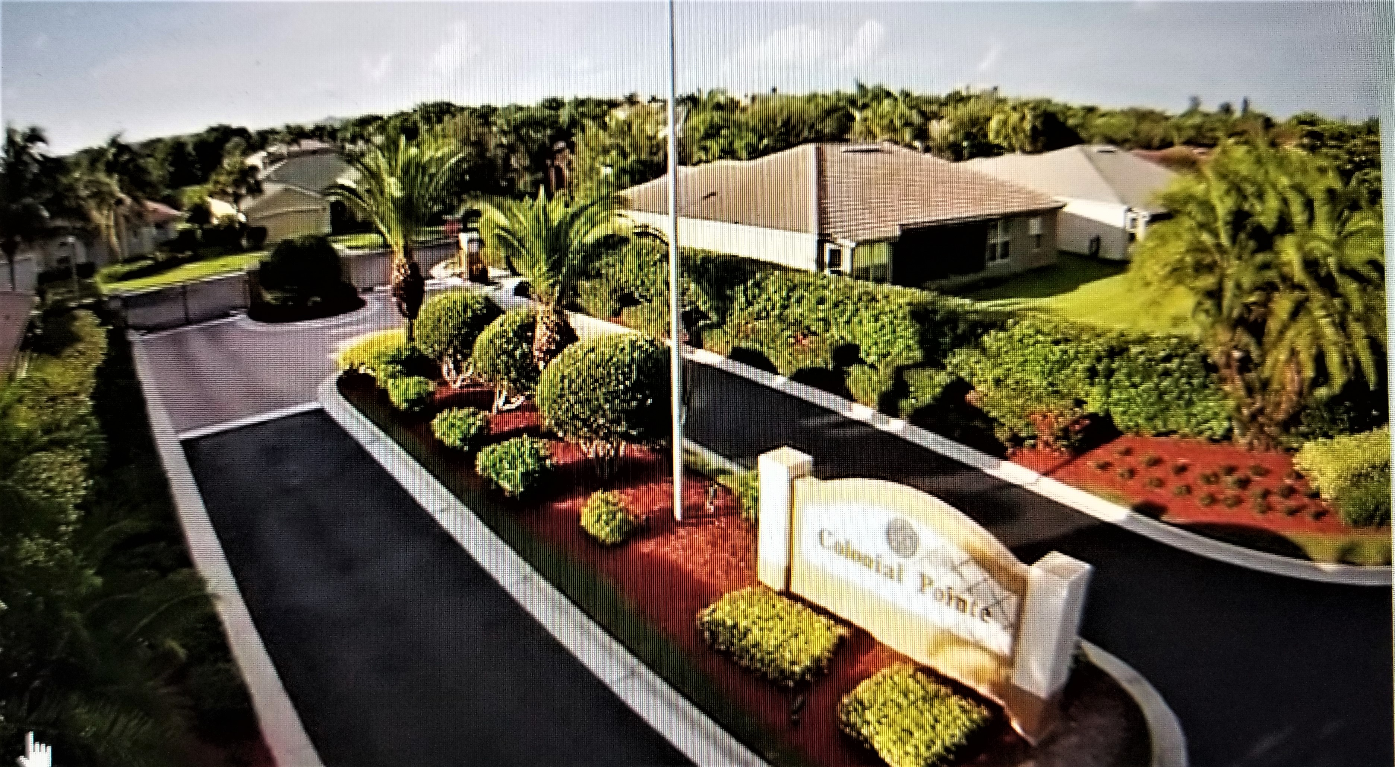
Colonial Pointe Newsletter
MAY 2025
matt@sandcastlePMB.com 239-466-3330
.

Dear Homeowner:

Colonial Pointe will be trimming the trees out front, along the south end of the property, in early July. Please be aware that the tree people may be on your property taking the debris that may fall in your yard. The contractor has asked that you do not approach the workers with requests. The contractor has offered to do individual trimming of PALM Trees ONLY. If you are interested in having him trim your PALMS, he has a limited number of trees he can cut on our timeline.
$25 per QUEEN Palms, $30 per CABBAGE Palm and $50 per COCONUT Palm
Please complete the form below, write your check and mail or drop it off to our management company, Sandcastle Property Management, 16266 San Carlos Blvd., Suite 10, Ft. Myers, FL 33908. Please write on the envelope : TREE TRIMMING PROJECT/COLONIAL POINTE. If not received by Friday, June 20, by noon, you will not be put on the schedule.
MAKE CHECK OUT TO : TLS Lawn and Tree Service
The form and check must be in Sandcastle’s office by NOON on Friday, June 20, 2025
Anything received after that cannot be scheduled.

Homeowner Name: ____________________ Address: 150_______ Balmoral Loop
# of Cabbage Palms _____ # of QUEEN Palms _____ # of COCONUT Palms _____

Total $ ________________ Check # __________________

